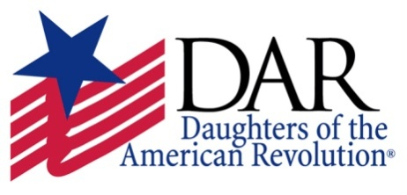
January 22, 2024

Dear Guidance Counselor,

The Rock Island Chapter Daughters of the American Revolution sponsors a $300 scholarship for a deserving college student from the Miller, Morgan, Moniteau County areas. This scholarship is awarded without regard to gender, race, national origin, or disability.

Scholarship applications will be available on or before January 31, 2024 and will be due by March 29, 2024. The winner will be announced in May at his/her school award ceremony.
Applicant must attend an accredited college or university in Missouri. The award will be submitted to the college or university upon verification of enrollment.
If you have any questions, please call or text me at the number given below.
Thank you for your time and assistance.
Sandy Pope, Scholarship Committee
573 286-5921
sjpopemore@gmail.com
350 Hwy CC, Eldon, MO 65026

