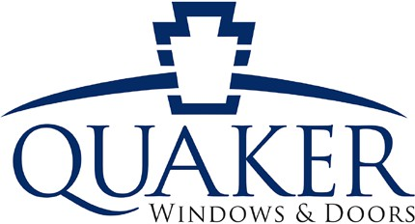
TMK Memorial Scholarship

The TMK Memorial Scholarship Fund was created in 2004, in memory of the late Tom Knoll, co-owner of Quaker Window Products at the time of his passing, to help assist deserving young adults with their educational pursuits. To date, the fund has awarded more than $166,000 in scholarship money to local high school seniors in their pursuit of higher education.

Eligibility
- Applicant must be a high school senior.
- Applicant must have a parent/legal guardian currently working at Quaker Window Products or the applicant must be an employee of QWP within the previous year.

Application Process
Candidates must submit the following materials to Bonnie Wieberg in Human Resources by Monday, March 25th, 2024:
- Applicant must complete application form below-type or print information in black ink.
- Applicant must compose an essay of no more than 250 words explaining your goals for the future and how this scholarship will help you achieve this goal.
- Essay must be typed in Arial font, size 12 and attached to the back of this application.
- Applicant must have two references-one personal reference and one teacher reference,
along with one letter of recommendation from either one of these references in a sealed envelope.
- Applicant must have a copy of his/her transcript through the 1st Semester of their senior year.
- Applications can be submitted by: drop off at Quaker (Human Resources Office), scan and email (bowieberg@quakerwindows.com), or mail to Quaker ( ATTN: Bonnie Wieberg PO Box 128, 504 US Hwy 63, Freeburg, MO 65035).
Note: Student receiving award must present class schedule for ﬁrst semester to receive the award. The
award will be paid to the accredited institution of higher learning.

Name: Birth Date:

Address:
City:
State:
Zip:

Parent/Legal Guardian that works at QWP: Tentative Major or Field of Study:

GPA:
Class Rank:
ACT/Date:

Name of School you Plan to Attend:
List school organizations & extracurricular activities. Include grade year involved, offices held,
scholarships & awards received.

Deadline to Apply: Monday, March 25, 2024

