
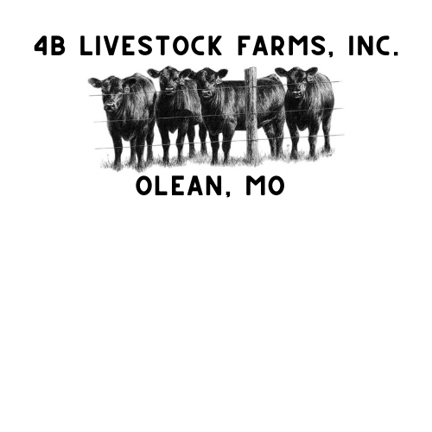
Don Bledsoe Memorial Scholarship

APPLICATIONS DUE:
March 17, 2026

The Don Bledsoe Memorial scholarship will be awarded to one eligible student in the amount of $500. To be eligible, you must meet and complete the following requirements.

- You must be a high school senior who attends Eldon High School.
- You must be an active member of the Eldon FFA Chapter and enrolled in an agriculture course.
- You must be planning to major in an agriculture-related field at a four-year university or community college.
- You must fully complete the application and answer the essay questions.
- Please attach a copy of transcript in a sealed envelope.
- You must enclose a letter of reference from a teacher or faculty member in a sealed envelope.

Name: ______________________________________________________________________

Address: ____________________________________________________________________

Students Signature: FFA Advisor Signature:

____________________________________ __________________________________

Please answer the following questions: (Maximum 1 page total for all three questions)

- What have you enjoyed most about your agriculture courses while being involved in the Eldon FFA?

- What made you want to further your education and specialize in the agriculture field after high school? And what career would you like to have with your agriculture degree?

- What does the agriculture industry mean to you?

The student that is selected as the recipient of the scholarship will be recognized at the Eldon FFA Awards Banquet in May 2026. A scholarship check will be given to the recipient following successful completion of the first semester with at least a 2.50 cumulative GPA.

